ROUND 2 Segment 1

1)The graph below shows the magnitude response of a system. The input signal contains frequencies ranging from 0 Hz to 1 kHz.

Determine what happens if an 800 Hz signal is applied as input.

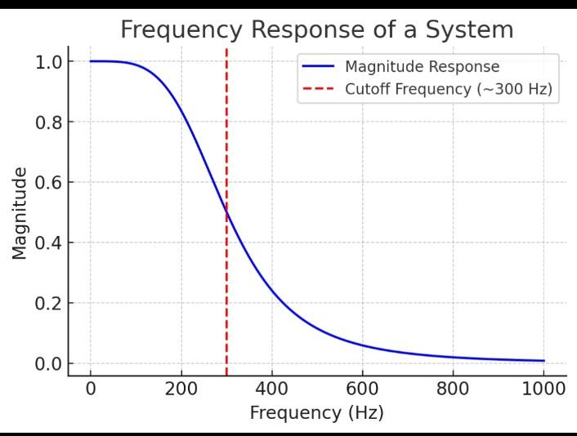

What happens if 800 Hz is input?

(A) Strongly attenuated

(B) Partially passed

(C) Fully passed

(D) Amplified

2)If the signal below is passed through a low pass filter that completely attenuates all AC components of the signal, what will remain at the output?

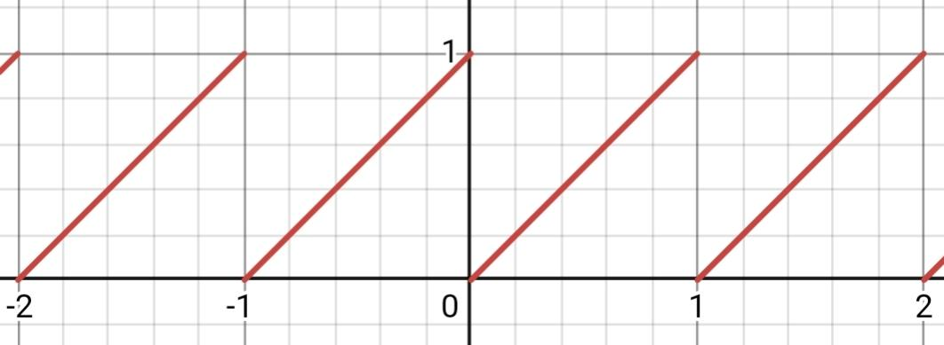

A)A majestic 0, because obviously there's no dc offset for the signal to ride like fremen on a worm

B) -1, choose if you just want to see the world burn like joker

C)0.5, that not so obvious one

D)1, what if the signal just wants to play it safe and stay high

3) Contruct the signal, [x]-x

Where [] is the greatest integer function.

a)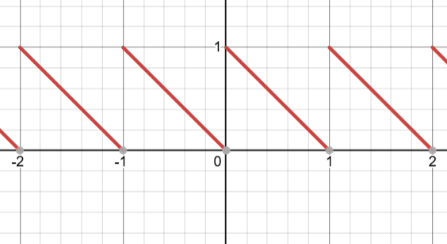b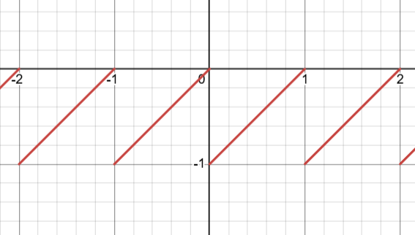

c)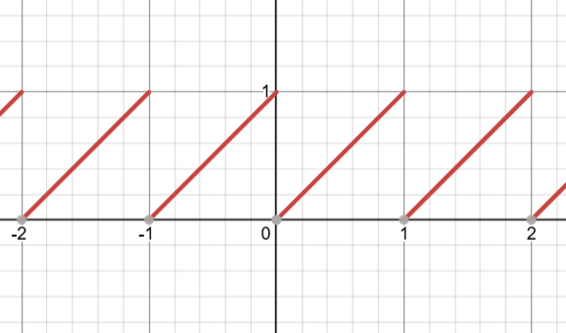d)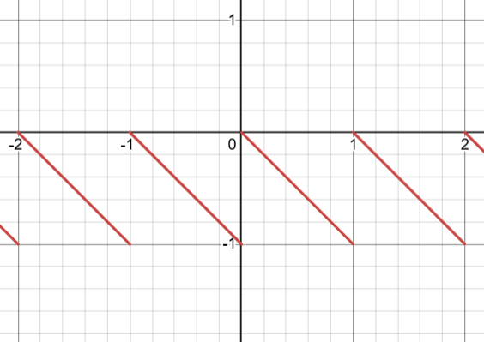

4) The waveform of three periodic signals, A, B and C, is shown in the figure below. If they are applied to the two Ex-NOR gate combinational circuit, then the frequency of the output wave ‘Y’ will be __ kHz.

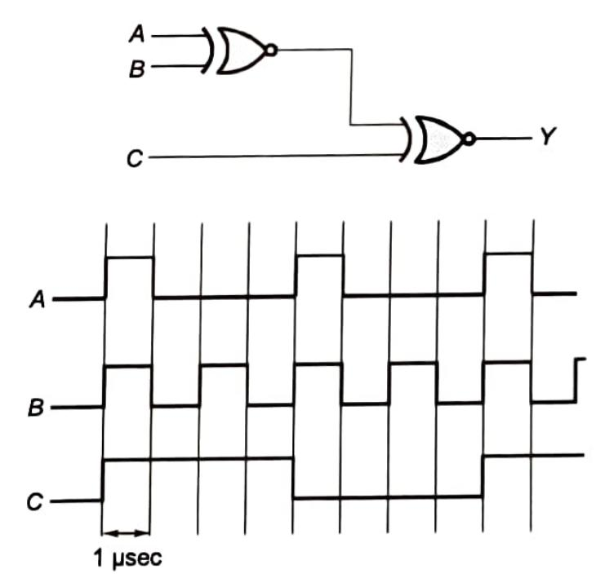

A)130khz

B)125khz

C)150khz

D)250khz

5)The input x(t) to an LTI system and impulse response h(t) of the system is given, and the output of the system is zero everywhere except for the time interval.

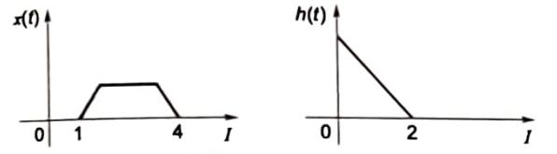

a)0 < t < 4

b)1 < t < 6

c)1 < t < 5

d)0 < t < 5

6) Which of the following waveforms will only have odd harmonics of sinusoidal waveforms?

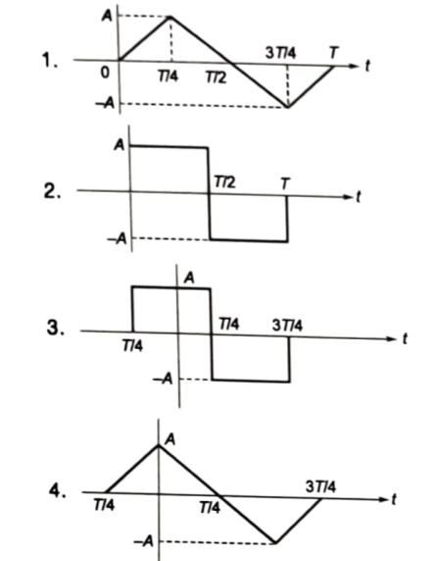

a)1 and 2

b)1 and 3

c)1 and 4

d)2 and 4

7)Match the system function with its impusl

esponse(hint: inverse laplace transform)

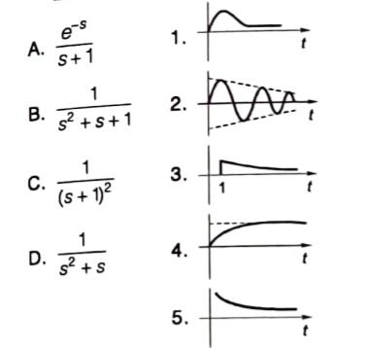

A B C D

a)3 4 1 2

b)5 2 3 4

c)3 2 1 4

d)5 4 3 2

8)The trigonometric Fourier series for the waveform f(t) shown below contains

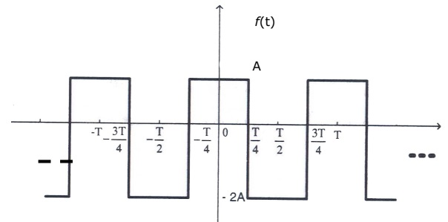

a)only cosine terms and zero values for the dc components

b)only cosine terms and a positive value for the dc components

c)only cosine terms and a negative value for the dc components

d)only sine terms and a negative value for the dc components

9)The function x(t) is shown in the figure. Even and odd parts of a unit step function u(t) are respectively,

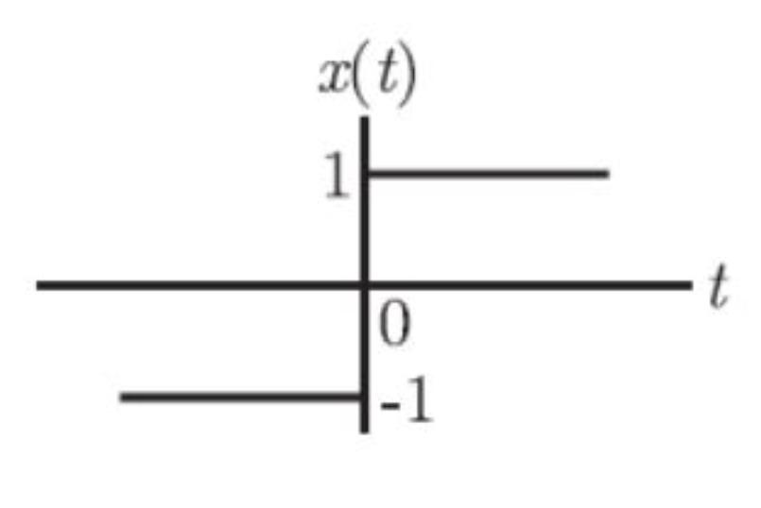

a)½ ,½ x(t)

b)-½ ,½ x(t)

c)½ , -½ x(t)

d)-½ , -½ x(t)

10)You're given with a spectrum, Determine the original signal  
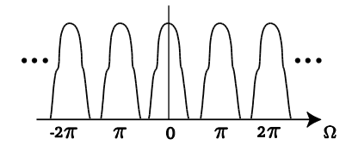

a)continuous, aperiodic

b)discrete, aperiodic

c)continuous, periodic

d)discrete, periodic

11) A signal has a maximum frequency component of 5 kHz. What is the minimum sampling rate required to avoid aliasing?

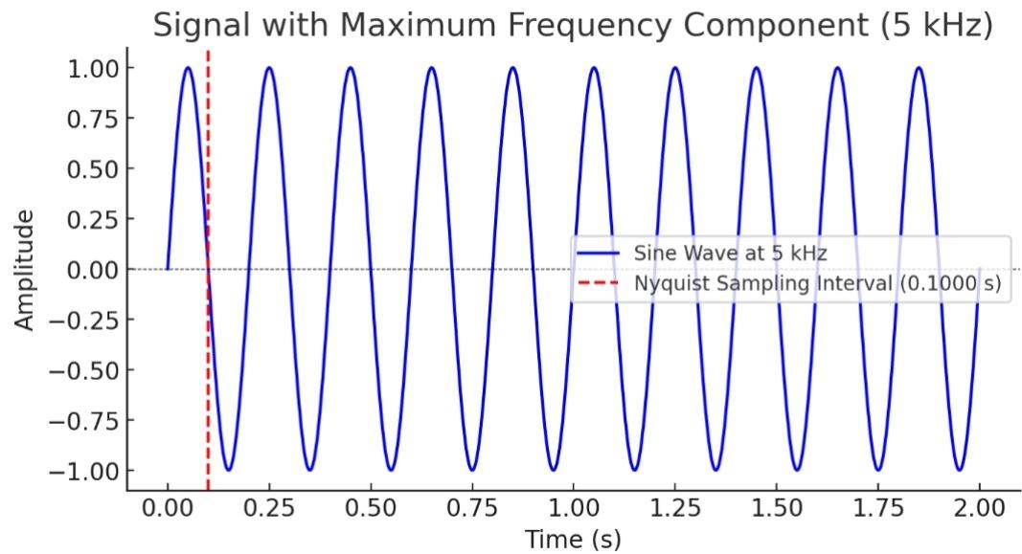

a) 2.5 kHz

b) 5 kHz

c) 10 kHz

d) 20 kHz

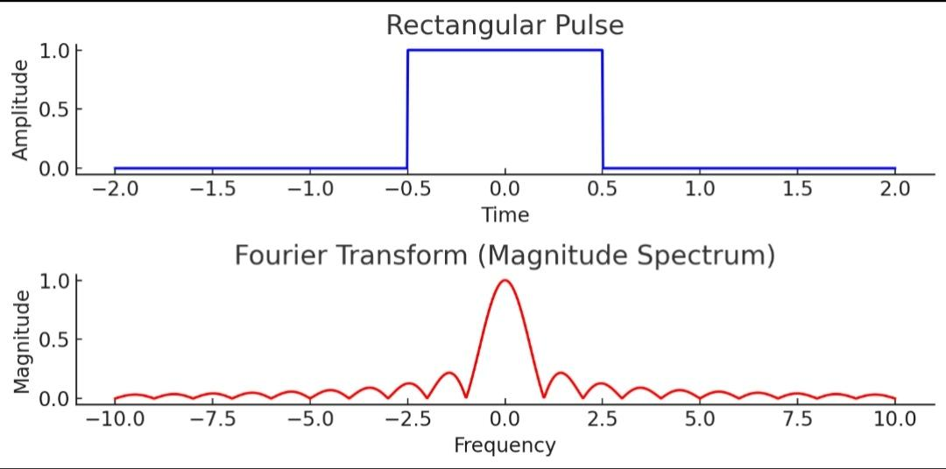

12) A rectangular pulse of width and amplitude is given. Which of the following represents its Fourier Transform?

a) Sinc function

b) Dirac delta function

c) A cosine function

d) A Gaussian function

13) How does increasing the number of bits in an ADC affect the staircase pattern in the graph?

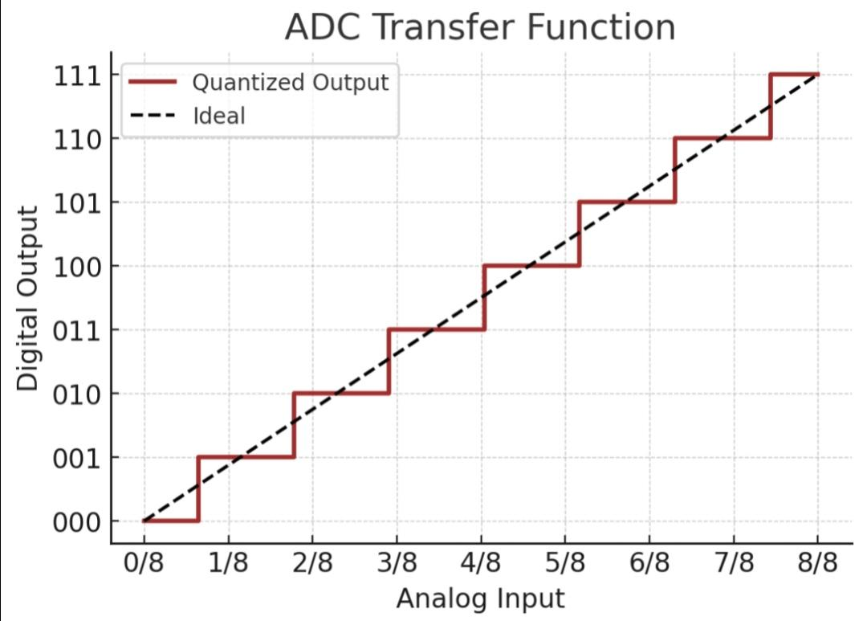

a) The steps become wider

b) The steps become narrower

c) The number of steps decreases

d) The ADC becomes non-ideal

14)A sequence x(n) has non-zero values as shown in figure.

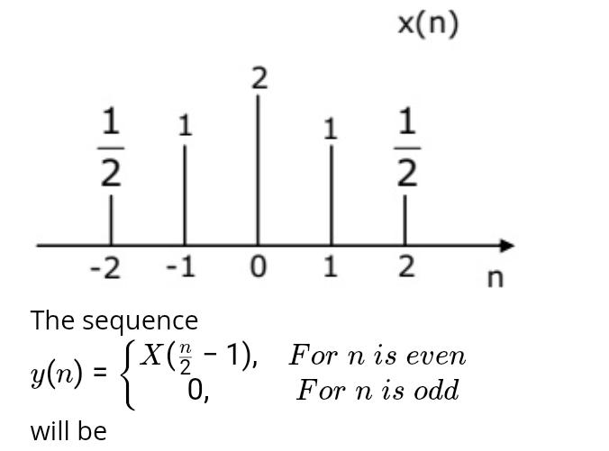

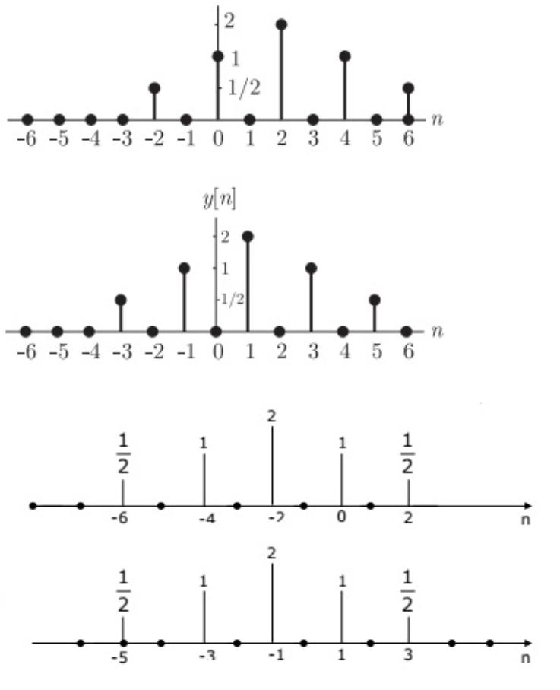

15)A 4-bit D/A converter is connected to a free -running 3-bit UP counter, as shown in the following figure. Which of the following waveforms will be observed at Vo?

